Assignment No.: 11
Problem Statement: Build scaling plans in AWS that balance the load on different EC2 instances.
Solution: 1.At first login to your AWS account and then go to EC2.
2. Then click on ‘Launch Templates’.
3. Click on the ‘Create Launch Templates’ option.

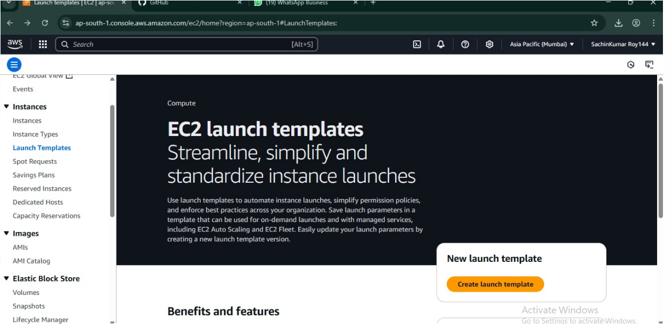

4. Put template name and check auto scaling guidance.

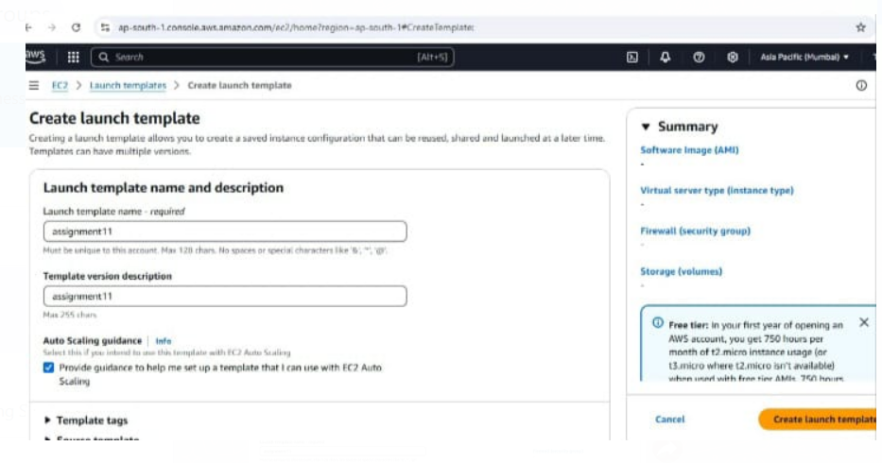
5. Select Ubuntu.
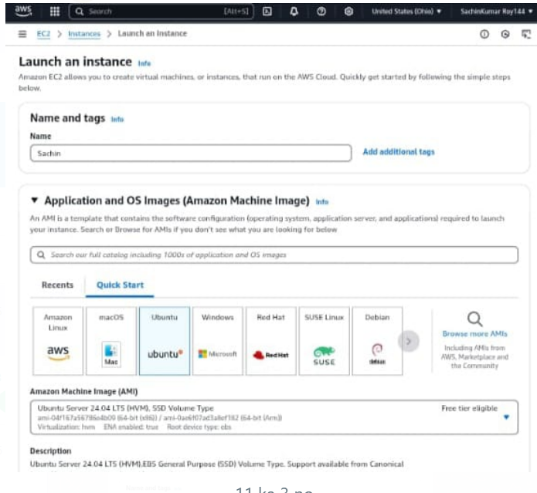

6. Select instance type t2.micro select key pair in firewall click select existing security group.
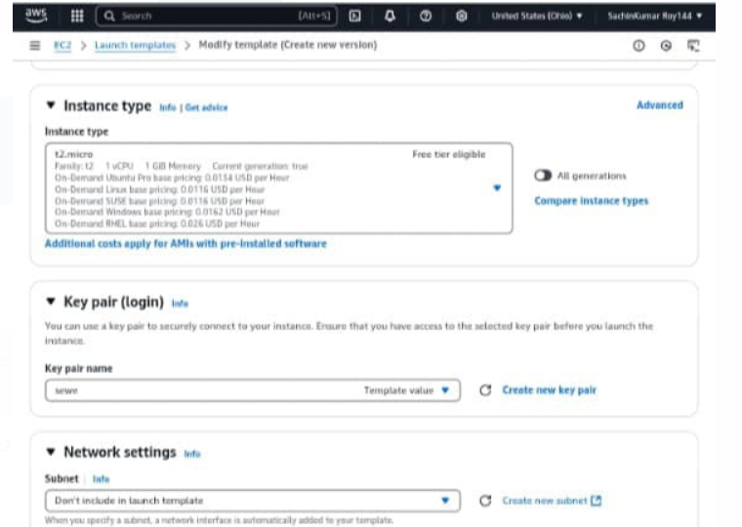
7.write the code and click on create launch template.

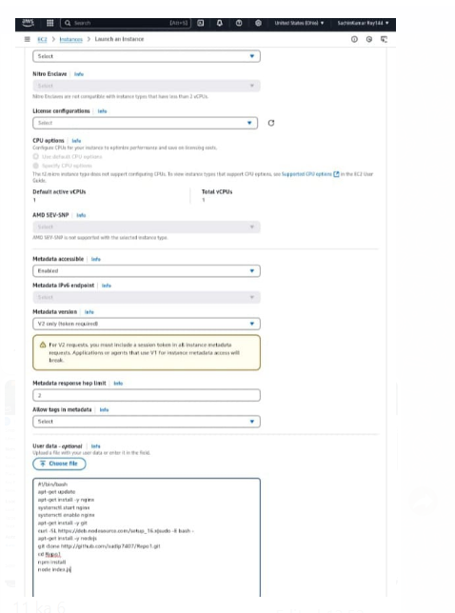

- Click auto scaling group.
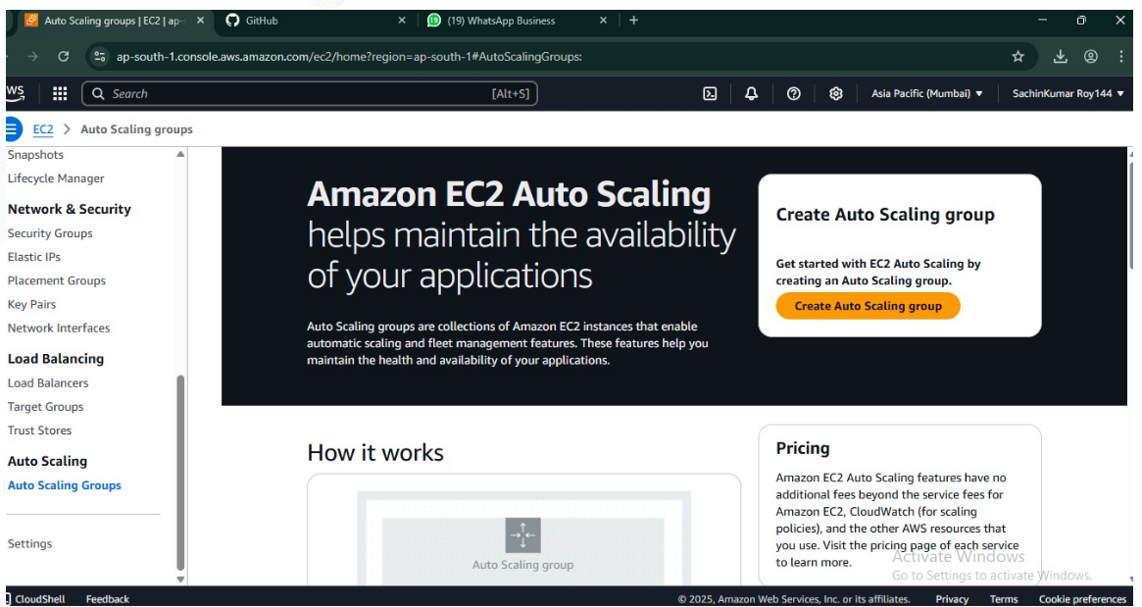

9. Give scaling group name select template.

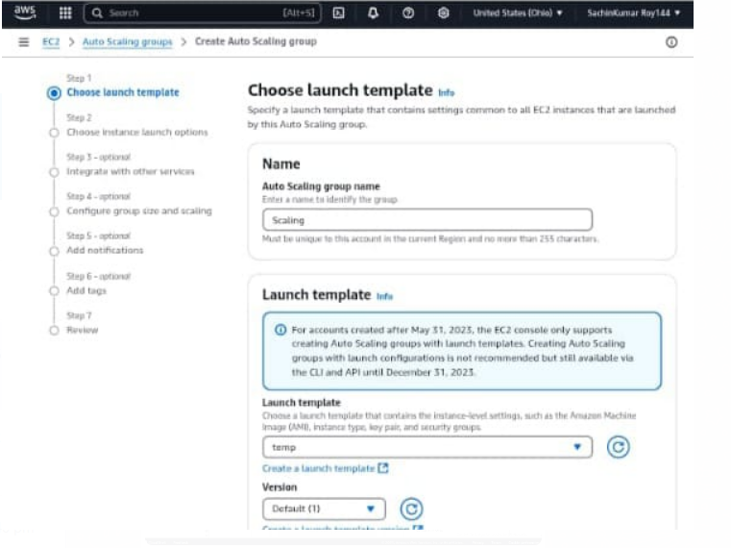

10. Select ap-south and Balanced best effort.

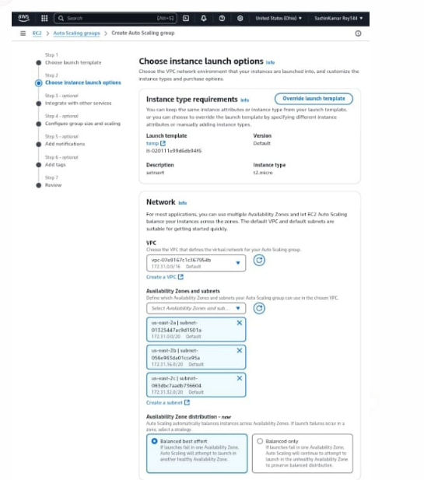

11. In step3 select (attach to a new balancer) and (application load balancer) and (internet-facing).
Write port (4000) select create a target group.
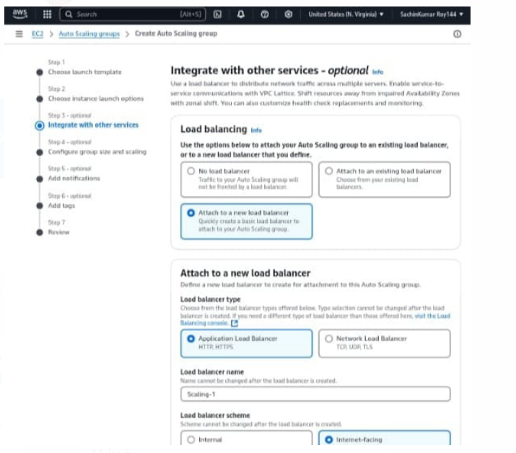

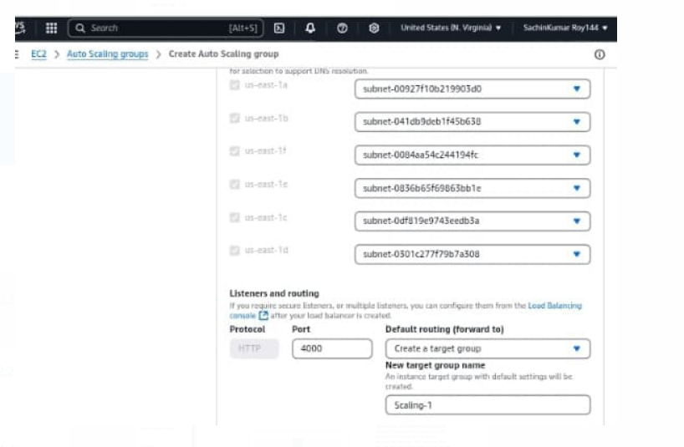

12. In step4 write desired capacity (2) min desired capacity (2) Max desired capacity (3) and click target tracking scaling policy.
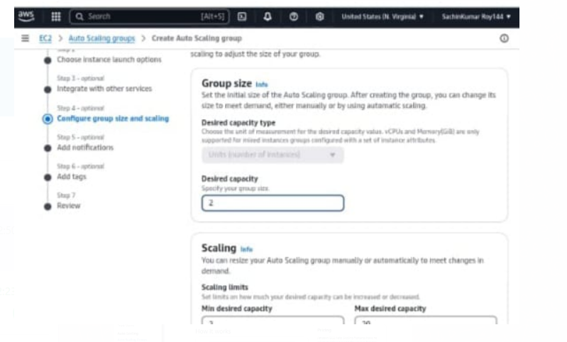
13. Write instance warmup (200).then step5 and step6 click next. 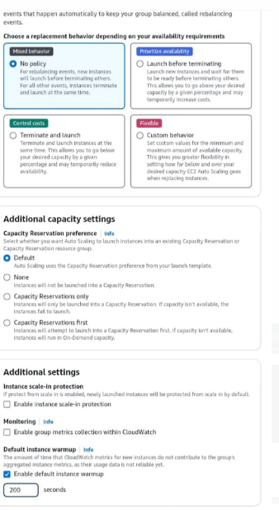
14.After that this is shown.
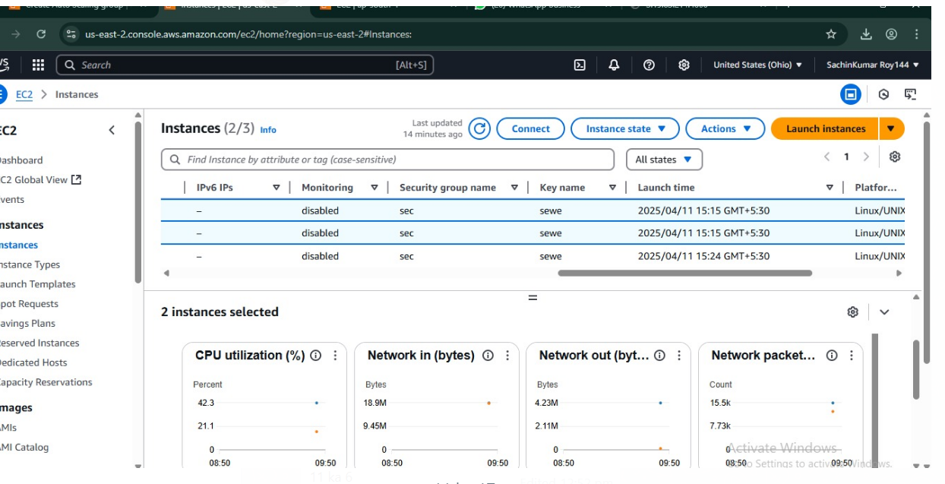

15.click on load balancer and copy the DNS name.
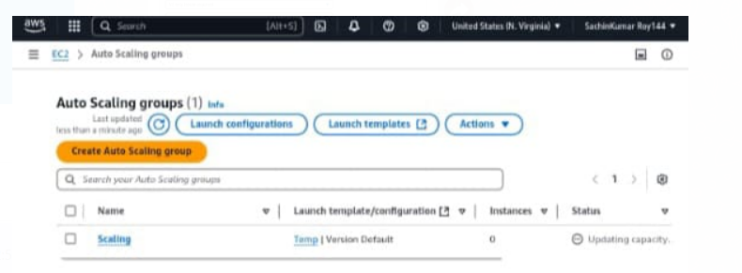

16. This page is shown, after paste the link.
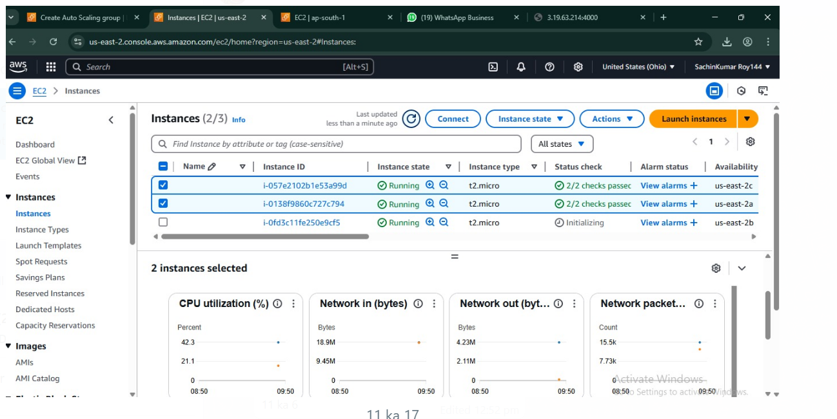
17. After successful installation, execute the .exe file to open the Bitwise SSH client 9.42 window. In that table, for host id paste the public IPv4 address of the created instance, for username type ‘ubuntu’, select initial method as ‘publickey’.
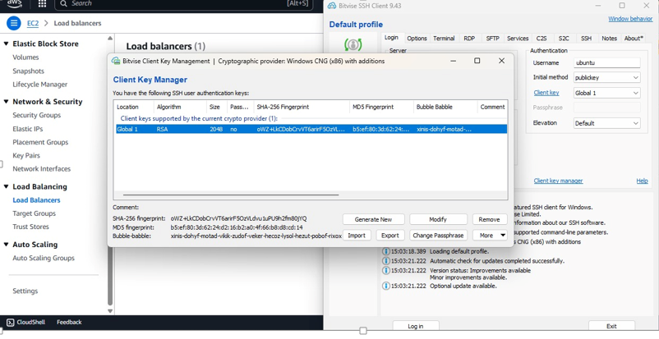
18. Write command.
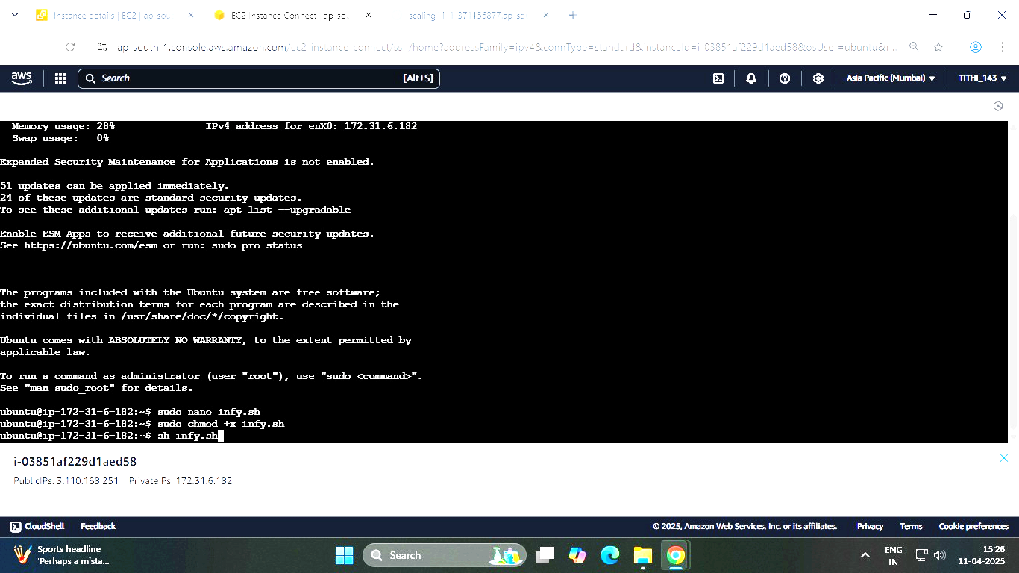

19.

